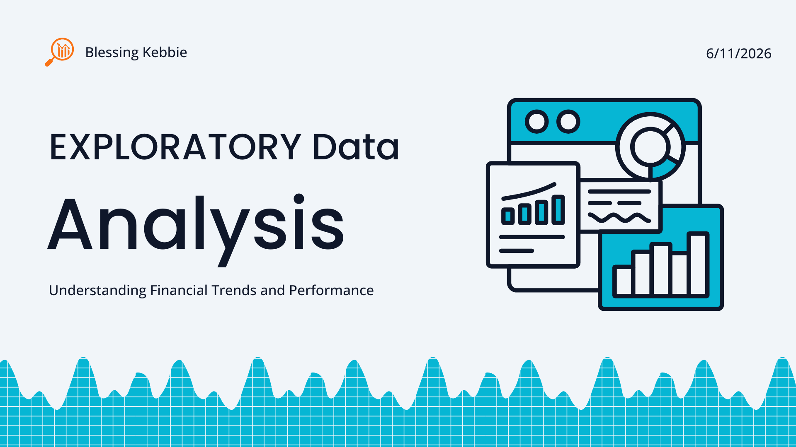
TABLE OF CONTENTS

EXPLORATORY DATA ANALYSIS (EDA) REPORT
Introduction
Exploratory Data Analysis (EDA) is a crucial step in data science that helps understand the structure, patterns, and relationships within a dataset. In this task, we analyzed a small employee dataset containing information about Name, Age, Department, and Salary. The goal was to explore the data, identify patterns, test assumptions, and detect any issues before further analysis.

Meaningful Questions Before Analysis
Before performing analysis, the following questions were asked:
- What is the structure of the dataset?
- What are the data types of each variable?
- What is the average salary of employees?
- Which department has the highest number of employees?
- Is there a relationship between age and salary?
- Are there any unusual patterns or anomalies in salary distribution?
These questions guided the analysis process.
Data Structure Exploration
The dataset contains 5 rows and 4 columns, as shown below:
Variables:
- Name → Categorical (String)
- Age → Numerical (Integer)
- Department → Categorical (String)
- Salary → Numerical (Integer)
Summary Statistics:
- Average Age: 28.4 years
- Average Salary: 3560
- Minimum Salary: 3000
- Maximum Salary: 4200
Key Insight:
The dataset is small and clean, with no missing values or duplicate entries.
Trends and Patterns Identified

Salary Distribution (Graph Analysis)
From the histogram (shown below), salaries are spread between 3000 and 4200.
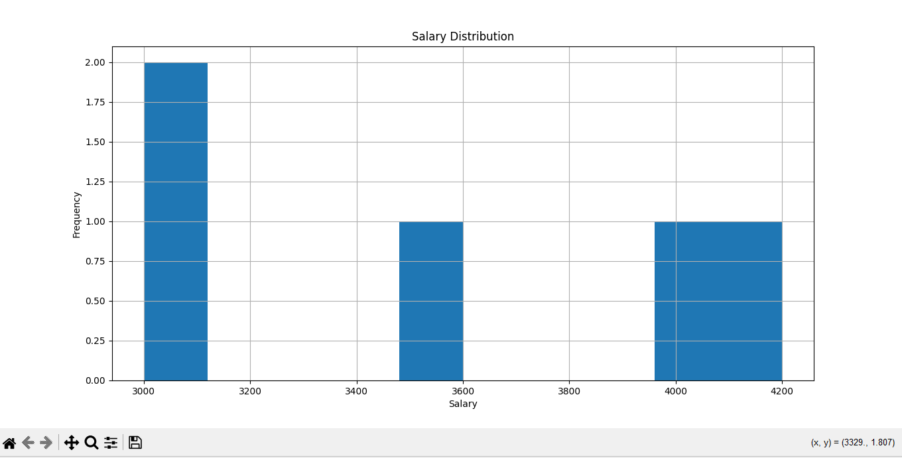
Observations:
- Most employees earn between 3000–3500
- Few employees earn higher salaries (4000+)
- The distribution is slightly uneven due to small dataset size
Department Distribution
- IT department appears more than others
- HR, Finance, and Marketing have fewer employees
Age vs Salary Relationship
A scatter plot was used to analyze whether age affects salary.
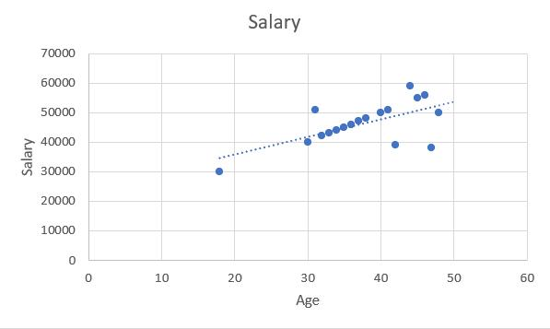
Observation:
- Slight positive relationship: older employees tend to earn slightly more
- However, the dataset is too small for strong conclusions
Hypothesis Testing & Assumptions
Hypothesis 1:
H₁: Salary increases with age
- Result: Weak positive relationship observed
- Conclusion: Partially supported

Hypothesis 2:
H₂: Departments affect salary levels
- IT employees show slightly higher salaries
- Conclusion: Possible relationship, but dataset is too small to confirm

6. Data Issues & Anomalies
The following issues were identified:
- Small dataset size (only 5 records)
- No missing values (good quality data)
- No duplicates found
- Limited variability makes strong conclusions difficult
- Cannot generalize findings due to small sample size
Final Insights
From the analysis:
- The dataset is clean and structured
- Salary ranges from 3000 to 4200 with moderate variation
- A slight relationship exists between age and salary
- IT department appears slightly more dominant in salary distribution
- No major anomalies or errors were detected

Conclusion
The exploratory data analysis successfully revealed the structure, patterns, and relationships within the dataset. Although the dataset is small, it provided useful insights into salary distribution and employee characteristics. Further analysis with a larger dataset would be required to make stronger statistical conclusions.

